Order Of Service

Singing: Psalm 72—CW page 93

Reading: Psalm 3

Opening Hymn: TLH 648

Reading: I Corinthians 5:9-13

Request Hymn: CW Supplement 750

Reading: Matthew 26:47-56

Sermon Hymn: TLH 30

Sermon Text: Luke 9:7-9

Who Is This?

Prayer

The Apostles’ Creed, TLH page 12

Holy Communion

The Lord's Prayer

The Blessing

Closing Hymn: TLH 31

* * * * * * * * * * *

Bible Study: Lambs: Eastern Bluebird
Sheep: Proverbs 31:19-22


North Shore, Lake Superior

Water
Of
Life

29 August 2021

W A T E R O F L I F E

Independent Christian Church—Conservative Lutheran Doctrine

Worship Service: 9:30 a.m. Bible Study: 10:45 a.m.

Larry Cooper, Pastor E-Mail address:
111 N. Ridge Road lcooper@wateroflife.cc
Coon Valley, WI 54623 Web Site:
www.wateroflife.cc

* * * * * * * * * * * * * * * * * * * * * * * * * * *

Sermon Text: Luke 9:7-9

Who Is This?

* * * * * * * * * * * * * * * * * * * * * * * * * * *

7 Now Herod the tetrarch heard of all that was done by him: and he was perplexed, because that it was said of some, that John was risen from the dead;
8 And of some, that Elias had appeared; and of others, that one of the old prophets was risen again.
9 And Herod said, John have I beheaded: but who is this, of whom I hear such things? And he desired to see him.

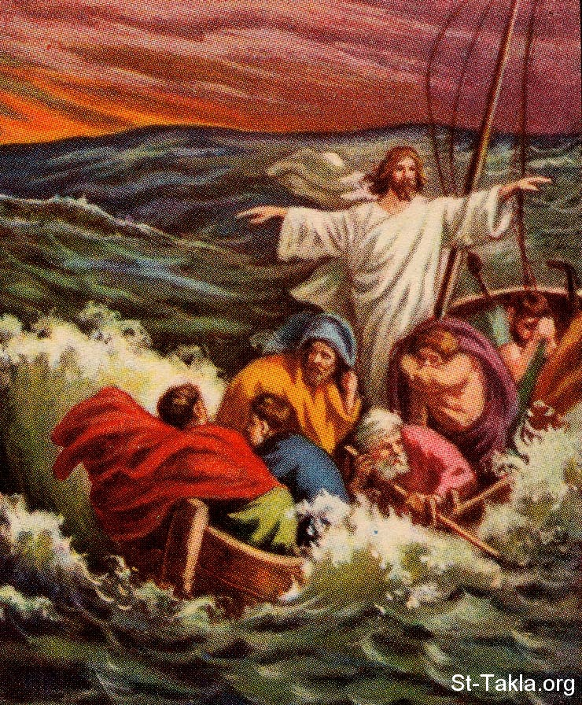

Who Is This ?

